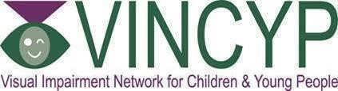

Medical Information Document
Cerebral Palsy and Cerebral Visual Impairment

What is cerebral palsy?
Cerebral Palsy (CP) is the name for a group of conditions causing children to have a difficulty with control of their muscles and movement due to a problem within the brain. It can occur if a baby's brain does not develop normally during pregnancy, or is damaged during or soon after birth.

It can affect children’s movement, coordination and posture in a wide range of ways. Different children are affected in different ways depending on which areas of the brain are damaged, or not fully developed.

Some children with cerebral palsy have only a mild form with minor movement difficulties, while others may be severely physically disabled.

Which other conditions can occur with cerebral palsy?
The brain damage or abnormality often affects other parts of the brain in addition to the movement areas so that children with cerebral palsy often can have other conditions including:
- intellectual disability
- seizures
- problems with speaking and communication
- eating and swallowing difficulties
- difficulty controlling saliva
- difficulties with sleep and behaviour
- hearing impairment
- cerebral visual impairment

Children with cerebral palsy are also much more likely to have poor control of their eye muscles leading to squint and poor focussing strength in the eye leading to need for prescription spectacles.

The following content explains how normal visual pathway works and provides more details on cerebral visual impairment.

What is the normal structure of the eye?

The eye works like a camera, capturing light and turning it into images that our brain can make sense of. Here is a breakdown of the parts of eye and how they work:

Light entry:

Light enters the eye through a clear window in the front of the eye called the CORNEA.
It then passes through a black hole called PUPIL.

Controlling the amount of light:

The PUPIL can get bigger or smaller to allow the right amount of light into the eye. The circle of muscle surrounding the pupil, forms the coloured part of the eye called the IRIS. The IRIS controls how big/small the pupil can be.

Focussing the light:

Behind the pupil is the LENS. This changes shape to focus the light onto the back of the eye and make images clear.

Image formation from the light:

The light sensitive inner lining of the eye ball is called the RETINA. This acts like the film in a camera. It contains special cells called RODS (that help to see in dim light) and CONES (that help to see bright light and colours). These special cells change the light into electrical signals, which can then be sent to the brain.

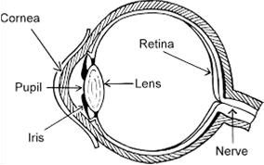

Sending visual signals to the brain:

Beyond the Eyes:

The electric signals from the retina are sent to the brain along a collection of thin wires called the OPTIC NERVE. The brain receives these electric signals, and turns them into a visual image which makes sense.

There are special “vision areas” in the brain. These areas process information sent from the eye to tell us information such as: What is the image I am looking at? Where is it? What colour is it? Where is it moving to? etc.

There are many different parts of the eye and the brain that need to work together in order for us to see well. The brain gets signals from the eye and sends these to the vision areas of the brain. In order for us to see, it is the brain that does most of the work. One way to think of this is that the eye is like a camera capturing pictures, and the brain is like a computer, processing the information and making sense of it.

Seeing Beyond the Eyes (in more detail)

As explained above, the retina changes light within the eye into electrical signals and then the optic nerve carries these signal to the brain (like a cable carrying an internet or TV signal). Each eye sends signals to both the right and left half of the brain. The optic nerve from each eye meet at a crossing point called the OPTIC CHIASM. Here, signals cross over from one side to the other and vice versa.

Most of the information is sent to the back of the brain (to the occipital lobes). The left occipital lobe sees the right side of the picture from the eye and the right occipital lobe sees the left side of the picture.

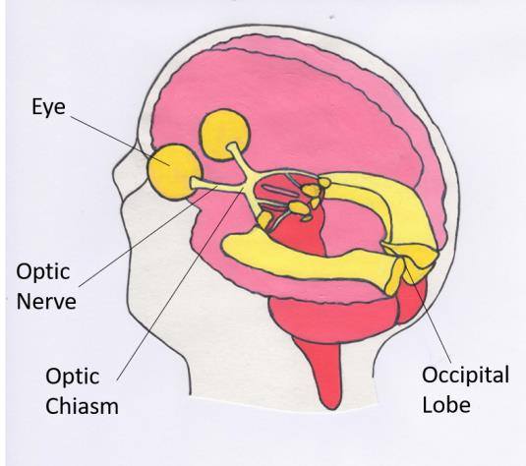

Figure 2: The Main Pathway for Information Travelling from the Eye to the Brain

After reaching the occipital lobe, visual information is then sorted out and sent to three other parts in the brain. Some of the information goes to the area of the brain called the posterior parietal lobes (these are near the top back of the brain). This is sometimes called the dorsal pathway. Some information goes to the temporal lobes (at the sides of the brain) and this is the where the visual memory is stored. This is sometimes called the ventral pathway. Information is also sent to and from the frontal lobes (which are at the front of the brain). This is the part that allows us to put information together. The posterior parietal lobes help us to see the whole picture and link up our movement with what we see, the temporal lobes help us to recognise things and the frontal lobes help us to choose what we look at and pay attention to.

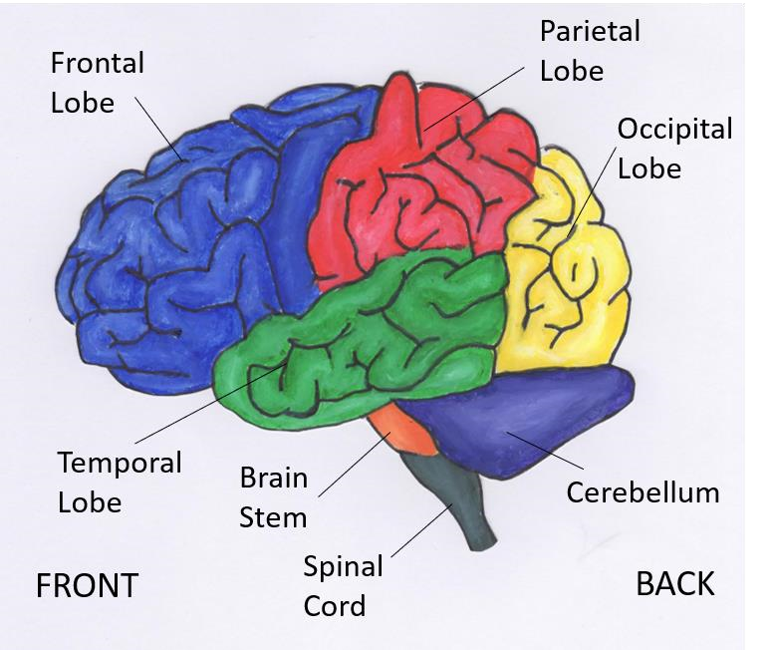 Figure 3: The Main Areas of the Brain

The visual brain is a very complex network where information is flowing back and forth all the time. All parts of the brain and eye need to work well. Difficulties with vision can occur if there is damage to any of these areas, systems or processes.

What is Cerebral Visual Impairment (CVI)?

Cerebral Visual Impairment (CVI) is the name given when someone is unable to see well, or can’t fully understand what they are seeing, due to some parts of the brain not working as they should. This condition used to be called cortical visual impairment. It is the most common cause of visual impairment in children within the UK.
CVI can happen if the brain has been damaged, or hasn’t developed in the usual way. The person may not see well, even though their eyes are working well. The brain is unable to make full sense of the picture the eyes are sending it.
CVI can affect people in different ways depending on which areas of the brain are damaged, or not fully developed. People with CVI are not all the same, and their vision can vary from having difficulty with only one specific thing, like recognising faces, to having no sight at all. In most cases, once the damage has happened, it does not get worse. As children grow and develop, they may learn to use their vision in better ways.

How is the diagnosis of Cerebral Visual Impairment made?
If a child or young person is suspected of having visual impairment, an assessment can be requested through their GP, or any children’s health service already involved. Firstly, standard vision tests and an eye examination will take place in the eye clinic. Some special tests such as electrophysiology may then be organised to test the connection between eye and brain.
It may be possible to diagnose Cerebral Visual Impairment at this stage but sometimes further assessment is required to understand the level of impairment.
If these eye tests are normal, or the results don’t explain the way the child looks at things, sees things or the way they move, then further assessments are needed. The child should then be assessed by a developmental Paediatrician to see if the way they behave is due to another problem such as a learning or movement difficulty.
If there is still no explanation for a child’s behaviour, then the child should have an assessment to look at the way their brain makes sense of what they see. This involves a team of professionals, asking questions about how the child sees and watching them do different kind of activities. This is often done in a specialist clinic and there are guidelines to help with diagnosis. Other tests such as brain scans (for example, MRI) may also be taken into account.

How does Cerebral Visual Impairment affect a child’s vision?
Most very young children with Cerebral Visual Impairment feel their vision to be ‘normal’ as they have never known anything else. They may think that everyone else has vision the same as their own and do not realise that other people see things differently.
How Cerebral Visual Impairment affects each individual can be very different depending on where the brain is damaged and any other associated problems the person may have. If there has been lots of damage to many parts of the brain, the vision can be very poor, but the person may still see movement and bright lights. Complete blindness due to brain damage is rare. Some people may have damage to a small area only and can see very well apart from that one specific problem.
Children with CVI might have problems with:
- Seeing clearly (blurry vision)

- Seeing all of peripheral visual field without moving their eyes, whilst focussing on one thing (field defect where some areas can be ‘missing’).

- Eye movements (this could be difficulty in following moving things or switching to look between one object to another- in other words, difficulty controlling their eyes to look at specific objects or having uncontrollable wobbly movement of the eyes called nystagmus)

- Seeing several things at once (visual crowding-‘overloaded’ with things to see, particularly seeing things against a cluttered background ;difficulty with this may be called problems with simultaneous perception of all objects in visual scene)

- Seeing things that move (missing things that move, difficulty crossing roads, seeing moving swings etc., or dyskinetopsia)

- Co-ordinating vision and movement together ( e.g. looking at something and being able to reach for it at the same time, difficulty copying, termed as problems with visually-guided movement)

- Visually engaging with things, particularly noticing more than one thing at a time (difficulty with this can be called problems with visual attention). This can often make the child appear to have a difficulty in their field of vision.

- Recognising objects or people (difficulty with this may be called problems with visual memory)

- Working out how close or far away things or people are from each other. (This can make it difficult for children to find their way around, judge stairs when walking, or write; difficulty with this may be called problems with orientation or visual spatial perception)

- Being slower to understand what they are seeing and respond to this.

Children can have one, several or all of these difficulties.

What can be done to help in Cerebral Visual Impairment?
There are no medicines or surgical treatments that will fix or improve damage to the brain. There are, however, lots of things that can be done to help children and young people with CVI use the vision they have better.
Changing the way things are shown to them can make a big difference to their development, learning, independence and happiness – the earlier this is done the better.
What can be done is dependent on the particular areas of difficulty a person has. At the time of diagnosis, a full assessment should identify which areas the individual has difficulty with, and what will help them.
What helps is different for different people and also dependent on their stage of development. Individual recommendations are made for each child or young person, depending upon their specific difficulties.
It is important to know and understand what your child sees so that you can give them the help they need. Young people themselves need to understand how and why they may see differently from others.
It is important that they are shown things that are big enough, bold enough and close enough that they can see them. Some children and young people with CVI need more time to look at things or may need to have them separated out to see them properly.
If glasses, contact lenses or Low Visual Aids (LVA) have been prescribed, it is important that these are used. These will help your child see more clearly and make sure the vision parts of the brain grow and develop correctly. Even if your child’s vision is very low, try to get them to wear their glasses if prescribed. This will help to give as clear a picture as possible to help get them interested in looking.
Even if a child has very poor vision, many useful and practical things can be done to help. All children and young people who have a visual impairment should have an assessment of their needs by a qualified visual impairment teacher and a qualified Habilitation specialist. These are the professionals who can give advice and support your child in learning, education and in practical and play activities.

Where can I find more information on Cerebral Visual Impairment?
There are many books, websites and papers on this subject. Not all professionals working in the area of CVI agree on everything about this complex condition. It is best to talk directly with the specialist health staff, qualified visual impairment teacher and qualified habilitation specialist involved with your child or young person, to discuss his/her particular difficulties and how to help them.

Approved: September 2025
Review Due: September 2028
NOTE
This guideline is not intended to be construed or to serve as a standard of care. Standards of care are determined on the basis of all clinical data available for an individual case and are subject to change as scientific knowledge and technology advance and patterns of care evolve. Adherence to guideline recommendations will not ensure a successful outcome in every case, nor should they be construed as including all proper methods of care or excluding other acceptable methods of care aimed at the same results. The ultimate judgement must be made by the appropriate healthcare professional(s) responsible for clinical decisions regarding a particular clinical procedure or treatment plan. This judgement should only be arrived at following discussion of the options with the patient, covering the diagnostic and treatment choices available. It is advised, however, that significant departures from the national guideline or any local guidelines derived from it should be fully documented in the patient’s case notes at the time the relevant decision is taken.

