

Visual Impairment Network for Children & Young People (VINCYP)

Pathway of Care embedding Getting it right for every child (GIRFEC)

2024

Contents
Introduction 3
Getting It Right For Every Child (GIRFEC) 3
Statutory Guidance – Assessment of wellbeing 3
Wellbeing Indicators 3
Team around the Child Meetings 4
VINCYP Pathway of Care 5
VINCYP Clinical Audit System 6
Multi-agency Referral System 6
Specialist Paediatric Service 7
VI Education Service 7
Habilitation Service 7
Third sector organisations 7
Multiagency Review 8
Childs Plan Meeting (TATC) 8

Introduction
The Visual Impairment Network for Children and Young People (VINCYP) was established in 2014 with the aim to improve the care for children and young people with a visual impairment. All children and young people with visual impairment (VI) should be fully assessed and have their needs identified and addressed appropriately by a team of trained professionals in a timely manner. They should also have access to the support they need from identification of the VI to post school transition, regardless of where they live.

The definition of Visual Impairment (VINCYP Criteria) is:

- Best corrected visual acuity (both eyes open) equal to or worse than 6/18 or 0.5 logmar
- Requires N18 print or larger to read comfortably
- Visual field loss with both eyes open which significantly affects function
- Any eye movement disorder which significantly affects visual function
- Any form of cognitive visual dysfunction due to disorders of the brain which can be demonstrated to significantly affect function

Getting It Right For Every Child (GIRFEC)
GIRFEC is Scottish Government’s commitment to provide all children, young people and their families with the right support at the right time, to help every child and young person in Scotland to reach their full potential.

GIRFEC provides Scotland with a consistent framework and shared language for promoting, supporting, and safeguarding the wellbeing of children and young people.

Following GIRFEC principles, all practitioners supporting CYP and their families, work together.

Further details on GIRFEC are available on Scottish Government website; www.gov.scot/policies/girfec/

Statutory Guidance – Assessment of wellbeing
The agencies who support a CYP with visual impairment have the specialist knowledge to identify the CYP’s needs using their professional knowledge and the SHANARRI wellbeing indicators as a guide.

Wellbeing Indicators
The wellbeing of CYP is at the heart of GIRFEC. There are eight wellbeing indicators which professionals, CYP and their families need to consider in order to ensure CYP grow, develop and thrive. The eight 8 indicators, often called SHANARRI indicators are:
- safe - protected from abuse, neglect or harm at home, at school and in the community.
- healthy - having the highest attainable standards of physical and mental health, access to suitable health care, and support in learning to help make healthy and safe choices.
- achieving - being supported and guided in their learning and in the development of their skills, confidence and self-esteem at home, at school and in their community
- nurtured - having a nurturing place to live, in a family setting with additional help if needed or, where this is not possible, in a suitable care setting.
- active - having opportunities to take part in activities such as play, recreation and sport which contribute to healthy growth and development, both at home and in the community.
- respected - having the opportunity, along with carers, to be heard and involved in decisions which affect them.
- responsible - having opportunities and encouragement to play active and responsible roles in their schools and communities and where necessary, having appropriate guidance and supervision and being involved in decisions that affect them.
- included - having help to overcome social, educational, physical and economic inequalities and being accepted as part of the community in which they live and learn
Further details of these definitions are available on the Scot Gov website: https://www.gov.scot/publications/getting-right-child-girfec-statutory-guidance-assessment-wellbeing-2022-part-18-section-96-children-young-people-scotland-act-2014/pages/9/
Using the GIRFEC principles, the approach to considering children’s wellbeing should be rights-based, strengths-based, holistic and adaptable enough to take account of stage of development and the complexity of each child or young person’s individual life circumstances.
“Where a child or young person requires the support of a specialist service, the specialist practitioner will have individual assessment tools to analyse information about a specific area of their needs. These specialist assessments form part of the holistic assessment of wellbeing where required, together with children, young people, families and others, and should be considered in the context of the child or young person’s life at home, in a learning environment and in the wider community.”

Team around the Child Meetings
Agencies ensure that needs are identified and addressed. Professionals work collaboratively for the benefit of the CYP and their families. Information is shared at Team Around the Child meetings to review progress and plan for next steps.
Further details on the Statutory Guidance – Assessment of wellbeing is available on the Scottish Government website - http://www.gov.scot/publications/getting-right-child-girfec-statutory-guidance-assessment-wellbeing-2022-part-18-section-96-children-young-people-scotland-act-2014/

VINCYP Pathway of Care
To help achieve these aims for children and young people with visual impairment a nationally agreed care pathway and standards of care have been developed as shown in diagram 1 below.

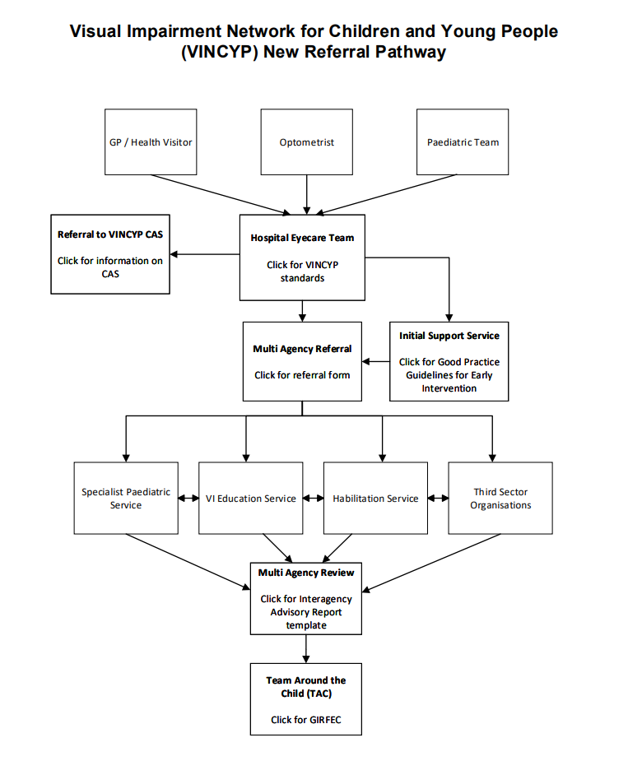
Diagram 1 – VINCYP Referral Pathway

As different agencies provide different services across the country, it is the responsibility of the local VI professionals to meet together to populate the pathway with the local service providers and to implement the pathway in their area.

The steps in the pathway are as follows:

Visual concerns usually present in primary care, or to the community optometrist (optician) or in paediatrics, and the first step is referral to the hospital eye team.

The hospital eye team includes ophthalmologists, orthoptists, hospital optometrists and specialist nurses. The team assess the child’s vision and the health of their eyes and carry out medical tests to find the cause of the child’s visual difficulties. The team identify the best treatment and ongoing monitoring of the child’s condition.

If the child is found to have a visual impairment fulfilling the VINCYP definition, the hospital eye team should:

- notify them to the VINCYP database
- refer the child to a professional with experience in visual impairment and counselling, for early support
- refer the child to community visual impairment services. This referral is made via the multiagency referral system which enables the hospital eye team to make a referral to all the appropriate VI services by making a single referral to a single point of contact.
- The central contact sends the referral simultaneously to the Specialist Paediatric Service, the VI Education Service, the Habilitation Service and third sector organisation which provides support for visually impaired people.

VINCYP Clinical Audit System
As part of the network’s audit and continuous quality improvement objectives, VINCYP continues to use the online database, Clinical Audit System (CAS) to record patient information.

This information is available to support Scottish Government, health boards and local authorities to show the prevalence of childhood VI in Scotland and is used improve service and financial planning in addition to supporting research.

Data collated in CAS is also used to generate transition letters that are issued to children when they reach 15½ years to inform them about the adult registration process.

Further details regarding the VINCYP CAS database can be found on the vincyp website – vincyp.scot.nhs.uk/uk/clinical-audit-system/

Multi-agency Referral System
The multi-agency referral system underpins the GIRFEC values and principles of:

- understanding wellbeing as being about all areas of life including family, community and society
- valuing difference and ensuring everyone is treated fairly
- considering and addressing inequalities
- providing support for children, young people and families when they need it, until things get better, to help them to reach their full potential
- everyone working together in local areas and across Scotland to improve outcomes for children, young people (CYP) and their families.

Specialist Paediatric Service
The Specialist Paediatric Service is part of the paediatric neurodisability or community child health team, which includes visual impairment paediatricians. A visual impairment paediatrician is a doctor who specialises in child development and visual impairment and has expertise in the diagnosis of cerebral visual impairment. They link closely and work with professionals in the hospital eye team, and also speech and language therapists, occupational therapists and physiotherapists, as well as professionals in the VI education service, habilitation service and 3rd sector organisations.

The Specialist Paediatric Service ensures that the CYP is Healthy by offering appropriate appointments and referring the CYP to other health services when required.

VI Education Service
The VI Education Service ensures that the CYP is Achieving in the learning environment, that toys/learning materials are accessible, and the environment supports learning. The service ensures that children are Nurtured by helping parents/school staff know how to support the CYP’s physical, learning, social and emotional learning needs. They support CYP to be Active, by ensuring that they have access to PE and Outdoor Learning experiences and promoting the work of local and national organisations such as Scottish Disability Sport and British Blind Sport. The VI Education Service works closely with CYP to ensure that they are Respected by listening to them and responding appropriately in discussions around learning and support. The service actively ensures that the CYP has opportunities at home and in school to be Responsible and is given the same opportunities as peers to take part and be Included in all aspects of family, school and community life.

Habilitation Service
The Habilitation Service ensures that the CYP is Safe when moving and travelling through space in both familiar and unfamiliar environments, commensurate with their age and stage of development. Orientation and Mobility Skills support a Healthy and Active lifestyle. Skills of Daily Living support CYP to be Responsible and Included.

Third sector organisations
Third sector organisations can offer support to help CYP feel Included and Nurtured within a community of others who have similar eye conditions. They can support CYP to be Active within their community and Respected for their own opinions.

Multiagency Review
Following assessment by the Specialist Paediatric Service, the VI Education Service, Habilitation Service and third sector organisation supporting people with a VI, the professionals involved share their assessments with one another to holistically identify the needs of the CYP. This includes reviewing a check list of all assessments carried out and consideration of any other assessment required in order to produce an Interagency Advisory Report (link)

Childs Plan Meeting (TATC)
As all the professionals involved are not able to attend the TATC meetings for the CYP because of conflicting work commitments, the QTVI in the VI Education Service presents the information from the Interagency Advisory Report at the TATC meeting to ensure all of the CYPs needs are addressed, and a plan put in place for them.

