**Paediatric End of Life managed Care Network (PELiCaN)**

Guideline for the use of Syringe Pumps in Children and Young People

*This document has been produced by the Paediatric End of Life Care Network (PELiCaN), Service Development sub-group. It has been adapted with kind permission from the Adult Syringe Pump Guidelines - Right Decisions Service, Scottish Palliative Care Guidelines Group.*

NOTE: This guideline is not intended to be construed or to serve as a standard of care. Standards of care are determined on the basis of all clinical data available for an individual case and are subject to change as scientific knowledge and technology advance and patterns of care evolve. Adherence to guideline recommendations will not ensure a successful outcome in every case, nor should they be construed as including all proper methods of care or excluding other acceptable methods of care aimed at the same results. The ultimate judgement must be made by the appropriate healthcare professional(s) responsible for clinical decisions regarding a particular clinical procedure or treatment plan. This judgement should only be arrived at following discussion of the options with the patient, covering the diagnostic and treatment choices available. It is advised, however, that significant departures from the national guideline or any local guidelines derived from it should be fully documented in the patient’s case notes at the time the relevant decision is taken.

**CONTENTS**

SECTION ONE: Introduction 5

SECTION TWO: Training and education 6

SECTION THREE: Before setting up an infusion 7

3.1 What is a portable syringe pump? 7

3.2 Component parts of the BD Bodyguard T syringe pump 7

3.3 When to consider using a syringe pump 8

3.4 Which subcutaneous sites are suitable? 9

3.5 Inserting a subcutaneous infusion device 9

3.6 Commonly prescribed medicines 10

SECTION FOUR: Setting up a syringe pump 10

4.1 Equipment 10

4.2 Battery 11

4.3 Documentation required 12

4.4 Preparing the medicines 12

4.5 Priming and connecting the subcutaneous extension line to the syringe 14

4.6 Loading the syringe onto the syringe pump 15

4.7 Using the Key Pad Lock 16

SECTION FIVE: Monitoring and maintaining the infusion 17

5.1 Monitoring the infusion 17

5.2 Renewing/changing the infusion 17

5.3 Stopping the infusion and removing the syringe pump 18

5.4 Temporarily stopping and resuming the infusion 19

5.5 What to do if a child or young person dies when their syringe pump is running 20

5.6 Child or Young Person Transfer 20

SECTION SIX: Safety & risk management 20

6.1 Syringe pump maintenance 20

6.2 Cleaning and decontamination 21

6.3 Incident reporting and hazard warnings 21

6.4 Hazard warning notification 22

SECTION SEVEN: Alarms and Troubleshooting 22

7.1 Alarm conditions 22

7.2 Contacts for advice 23

REFERENCES 24

RESOURCES 24

APPENDICES 25

APPENDIX 1: Syringe Pump Version Differences 25

APPENDIX 2: Standard Operating Procedure (SOP) Template for Syringe Pumps 26

APPENDIX 3: Information Leaflet 28

APPENDIX 4: BD Guidance to Changing Date and Time Setting 30

Appendix 5 – Working Group Members and Approval 31

The PELiCaN Service Development Group have endeavoured to create as complete a document as possible, however, if you have any constructive feedback or comments on this document this would be greatly appreciated. You can do this by emailing the team on [nss.pelican@nhs.scot](mailto:nss.pelican@nhs.scot) or by completing the following [feedback form](https://forms.office.com/Pages/ResponsePage.aspx?id=veDvEDCgykuAnLXmdF5JmuBVAwUjZalBu7dlhOa8DbZUM1lZU1c1VzYySE9ZOU9OWEhCU09KWjdBTCQlQCN0PWcu). **NB:** All PELiCaN documents will be subject to NSS document governance and will be subject to regular review.

**Document Governance**

|  |  |
| --- | --- |
| **Rationale for creating the guidance** | This guidance document was developed to ensure there was appropriate advice in place for professionals working in paediatrics, to compliment the Scottish Palliative Care Adult’s Guideline of this process. |
| **What stakeholders were involved** | * Nursing and Medical Professionals * Pharmacy |
| **Methodology used** | * Scoped current processes in Boards * Considered best practice * Adapted adult’s guideline * Ratified by Steering Group and adults’ group (TBC) |
| **Scope** | This guideline is for the use of syringe pumps in babies, children and young people receiving palliative care or end of life care. And to provide a consistent training and education framework to support staff administering this treatment in Boards. |
| **Review dates** | Feb 2028 |

|  |  |  |  |
| --- | --- | --- | --- |
| **Version** | **Description of amendments** | **Name & Designation** | **Date** |
| V1 | First draft | Shelley Heatlie  Programme Manager | Feb 2025 |
|  |  |  |  |

## SECTION ONE: Introduction

This guideline is for the use of syringe pumps in children and young people only. It has been produced with kind permission of the authors of the newly published Adult Syringe Pump Guideline. The adult guideline was first produced in 2011 by NHS Education for Scotland (NES) in consultation with practitioners in hospital, hospice and community settings throughout Scotland.It was then reviewed in 2023 as part of the Scottish Palliative Care Guidelines review and maintenance process.

In this guidance document we use the term ‘child or young person’, by this we mean any baby, child or young person you may be caring for.

**Aims**

* To support safe, effective, person centred care across NHS Scotland and CHAS when using the portable syringe pump for children and young people receiving palliative care or end of life care.
* To provide consistency in the training and education framework to support staff competency.

The syringe pump referred to throughout the main body of the document is the Becton Dickinson (BD) Bodyguard T. Other syringe pumps are available for use throughout Scotland, namely, the T34 Version 2 and CME Version 3. A summary of the differences between the pump versions is outlined in Appendix 1. Please check which syringe pump(s) are used in your local area by referring to local Standard Operating Procedure (SOP).

Our thanks go to Becton Dickinson for their kind permission to use images of the Bodyguard T within these guidelines. Further information by the manufacturer (Becton Dickinson) can be accessed here: [BD BodyGuard T - BD](https://www.bd.com/en-eu/offerings/capabilities/infusion-therapy/infusion-system-devices/bodyguard-ambulatory-system/bd-bodyguard-infusion-pumps/bd-bodyguard-t).

**Local variations**

These guidelines are intended to support best practice in a range of settings however we recognise there may be differences in local systems, procedures and equipment. Boards will need to consider, identify and manage any local variations from the national guideline. A table highlighting items for consideration in a local Standard Operating Procedures (SOP) document or similar has been provided: see Appendix 2

## SECTION TWO: Training and education

All staff using syringe pumps for continuous subcutaneous infusions must be appropriately trained and assessed as competent. Registered nurses are accountable for ensuring their practice is evidence based and that they are competent in accordance with *The Code: Professional standards of practice and behaviour of nurses and midwives* (2018).

Each organisation has a responsibility to ensure staff are provided with the appropriate training and education. All managers should ensure competency is achieved and keep an up-to-date staff record.

Using a syringe pump is a practical, clinical skill. Therefore, education and training should follow a clinical skills approach. This approach supports the learner with the theory required to carry out the skill, a practical demonstration(s), often in the clinical area, and the opportunity to practice and develop this skill (Burgess et al, 2020).

Supervised practice continues until the learner and supervisor feel competency has been achieved. Once competency is achieved, a record should be kept by the learner, supervisor and manager. It is the responsibility of the nurse to ensure they maintain their competency as per local practice education guidance.

## SECTION THREE: Before setting up an infusion

This section provides information and guidance on what is required before a subcutaneous infusion is commenced via a syringe pump.

### 3.1 What is a portable syringe pump?

The Bodyguard T syringe pump is a portable, battery operated device for delivering medicine by continuous subcutaneous infusion (CSCI) over a 24-hour period. Syringe pumps provide an alternative route for pain and symptom management in palliative care.

### 3.2 Component parts of the BD Bodyguard T syringe pump

**Key pad features:**

* **i+** key: shows infusion summary, battery status, event log and key pad lock/unlock feature
* Up and Down keys enable scrolling up and down the menu
* 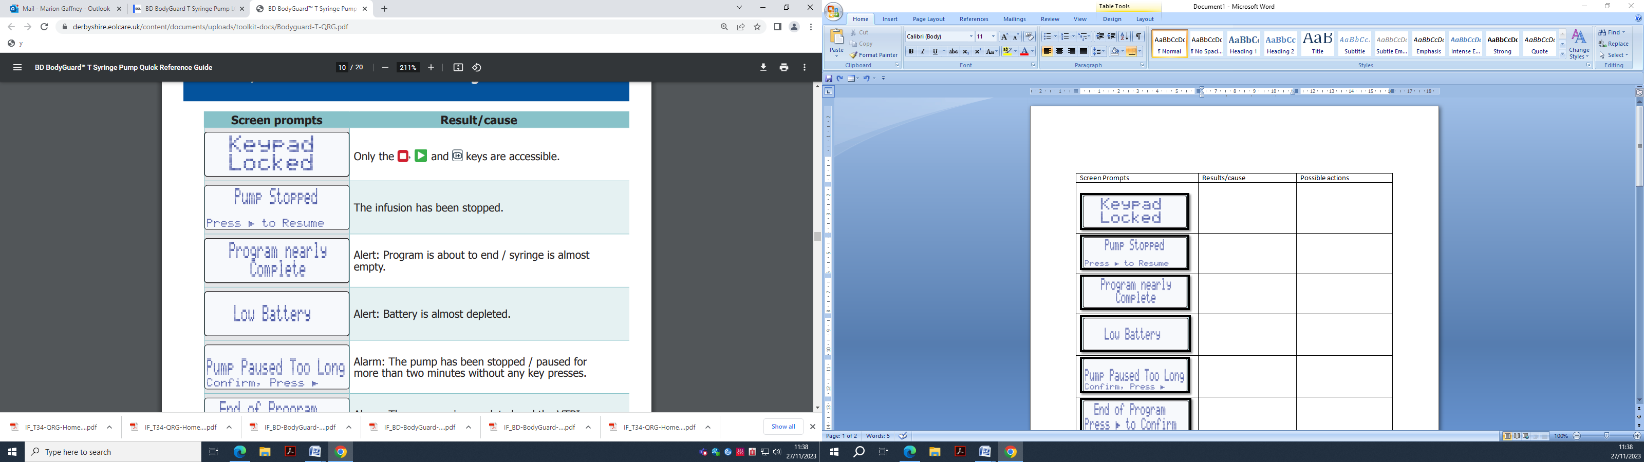 confirms selection and starts the infusion
*  responds to no to selection and stops infusion
* key moves the actuator to the right
* key moves actuator back to the left
* Infusion light flashes **GREEN** when infusion running and **RED** when stopped
* Switch Saymbol - ClipArt Best switches pump on and off

### 3.3 When to consider using a syringe pump

The use of a syringe pump can sometimes be associated with end-of-life care. Before setting up the syringe pump, it is important to discuss the reasons for use with the child or young person, family or carer. The discussion should include an explanation of how the pump works and how to respond to any incidents which may occur.

An information leaflet is available for children and young people, families and carers: see Appendix 3. This should be offered across all care settings.

**MOST COMMON REASONS FOR USE:**

**Oral/enteral route compromised:**

* Difficulty swallowing
* General condition deteriorating

**Oral/enteral route less effective:**

* Intractable nausea and vomiting
* Gastro-intestinal malabsorption
* Gastro-intestinal obstruction

Other less common situations may arise, when using a syringe pump could be beneficial, but the decision should be discussed and agreed between the child or young person, the wider multi-professional team and other colleagues e.g. Specialist Palliative Care, Pharmacy.

**Advantages include:**

* The delivery of therapeutic medicine levels over a 24-hour period
* May reduce need for regular subcutaneous bolus injections

**Disadvantages include:**

* Access to subcutaneous sites may be limited because of long-term infusions
* Site reactions e.g. redness, bleeding, leakage, inflammation, blanching and infection
* Child or young person may find the pump restrictive e.g. unable to move freely, daily refill required

### 3.4 Which subcutaneous sites are suitable?

Where possible, involve the child or young person in the choice of suitable site(s). Ensure the area chosen has loose, subcutaneous tissue.



**Acceptable subcutaneous sites:**

* Outer arm
* Upper thigh
* Abdomen
* Chest wall
* Scapula (for someone who is confused or delirious)

**Sites to avoid:**

* Oedematous / lymphoedematous sites/ abdominal ascites
* Bony prominences/ areas at risk of displacement e.g. waistband, near joints/skin folds
* Irradiated areas /broken skin

### 3.5 Inserting a subcutaneous infusion device

To minimise the risk of occlusion and site complications, it is essential that the device is inserted correctly. Refer to your local or device policy.

Refer to local or manufacturer policy on how long a device can remain in situ. The date of insertion should be written on the site dressing and on the recording chart. In some circumstances, it may be appropriate to leave the device in place longer provided the integrity of the site remains e.g. limited options for new sites.

Decisions regarding the subcutaneous device ~~s~~hould be risk assessed, and the rationale recorded on the recording chart. If the device is unused for 24 hours, check the patency by flushing with a compatible solution e.g. 0.9% Sodium Chloride or Water for Injections. Remove the device when no longer required.

**KEY POINT: A single port, subcutaneous infusion device should be used for the administration of medicines via a syringe pump. An additional device should be inserted for the administration of bolus subcutaneous medications. This helps to ensure the syringe pump delivers the prescribed medicines over a 24hr period without interruption.**

### 3.6 Commonly prescribed medicines

The groups of medicines listed below are commonly prescribed for use in syringe pumps to help manage a range of symptoms.

* Analgesics
* Anti-emetics
* Sedatives
* Anti-epileptic
* Anti-secretory

Occasionally medicines may be used out with a manufacturers licence or ‘off-label’ in palliative care e.g. via the subcutaneous route. This practice carries additional responsibilities for prescribers, pharmacists and nurses: see section [‘off label and unlicensed prescribing’](https://rightdecisions.scot.nhs.uk/mypsych-app/working-in-greater-glasgow-clyde/medicines-companion/non-formulary-unlicensed/off-label-and-unlicensed-prescribing/) on Scottish Palliative Care Guidelines.

**KEY POINT: The preferred route for the administration of medicines remains oral/enteral (where possible).**

All medicines administered via the syringe pump should be clearly and correctly prescribed in accordance with local policy and procedures.

Further information and prescribing advice can be accessed on the Association for Paediatric Palliative Medicine Master Formulary: [Home | Association for Paediatric Palliative Medicine (APPM)](https://www.appm.org.uk/) or the Scottish Palliative Care Guidelines: [Scottish Palliative Care Guidelines](https://rightdecisions.scot.nhs.uk/scottish-palliative-care-guidelines/)

## SECTION FOUR: Setting up a syringe pump

It is recommended you familiarise yourself with the equipment used in your area of practice/setting and are aware of local variations: see Appendix 1

### 4.1 Equipment

* Bodyguard T syringe pump (or equivalent)
* Luer lok syringe
* Extension line (refer to local guidance)
* Needleless/SafeSharp subcutaneous device
* Good quality 9 volt (6LR61) alkaline battery
* Transparent adhesive dressing
* Smaller syringes and needles to prepare the medicine(s)
* Sharps bin
* Personal Protective Equipment (as required)

The size of syringe selected to prepare the medicine(s) will depend on the volume of the medicines prescribed including diluent. The total volume generated will determine the size of the syringe.

The volumes below provide an average maximum volume.

* 20ml – maximum volume **17mls**
* 30ml – maximum volume **22mls**
* 50ml – maximum volume **34mls in exceptional circumstances. Risk assess prior to use.**

*Please note a 50ml syringe cannot be accommodated by the majority of lockboxes.

**Lockbox / Cover**

The Bodyguard T syringe pump should be set up with a lockbox and placed in the bag. Please refer to local policy and procedures.

### 4.2 Battery

BD recommend only using 9V 6LR61 non-rechargeable batteries. Before using the pump, the following actions should be taken.

* Always check the battery power before commencing an infusion
* Press the **i+** key until the battery level option appears on the screen and then press  to confirm
* If the battery power has less than 75% life remaining at the start of an infusion, then a new battery should be installed
* Report any problems with battery connections to your local Medical Physics department.

BD recommends leaving the battery in the Bodyguard T pump however please check local policy and procedures. If the battery has been removed from the syringe pump between uses, ensure the date and time are accurate on set up. Guidance on resetting the time & date: see Appendix 4

**KEY POINT: The battery level can reduce significantly when alarm conditions are activated during the infusion.**

**The low battery alarm provides warning at least 30 mins before the battery ends. If the battery is not replaced, a backup buzzer will sound for 3 minutes, and the pump will then shutdown.**

**Please consider the environment where the syringe pump is being managed and how the nursing team can respond to the need for a battery change. For example, community settings should confirm the battery level is sufficient to complete the delivery of the full infusion.**

### 4.3 Documentation required

The following documents are used to support the administration of medicines via a syringe pump:

* Continuous subcutaneous infusion **‘Prescription Chart’**
* Continuous subcutaneous infusion ‘**Recording Chart’**
* Medicine additive label

For the purposes of this guideline, the term ‘recording chart’ has been used to refer to the document used to prepare, monitor and record continuous subcutaneous infusions however this varies across different organisations. All sections should be completed in accordance with local policy and procedures.

### 4.4 Preparing the medicines

Syringe pumps are commonly used to deliver one, two or three medicines over a 24-hour period. Some Health Boards accept the delivery of more than three medicines in one syringe pump however this is often under the advice from specialist or pharmacy services. Please refer to local policy and guidance. The mixing of medicines in this manner is unlicensed but is supported by practice. Medicines should only be mixed if known to be compatible. The diluent must also be compatible with the medicines prescribed.

**KEY POINT: If Dexamethasone or Cyclizine are prescribed, these should be added once all other medicines are diluted. These medicines are the most common causes of incompatibility.**

Further information and advice is available via Specialist Palliative Care Teams, Pharmacy, and the Scottish Palliative Care Guidelines - [Compatibility and stability tables for subcutaneous infusion | Right Decisions (scot.nhs.uk)](https://rightdecisions.scot.nhs.uk/scottish-palliative-care-guidelines/symptom-control/syringe-pumps/assessment/compatibility-and-stability-tables-for-subcutaneous-infusion/) and [Medicines Complete - Drug Compatibility Checker](https://www.medicinescomplete.com/#/compatibility).

**Mixing syringe contents:**

1. Select and check compatibility of diluents and prescribed medicines
2. Draw up each of the medications require individually into appropriately sized luer-lok syringes
   * Glass ampoule use filter needle or drawing up, then remove and replace with safety needle
   * Plastic ampoule use safety needle to draw up and leave attached
3. Calculate the volume of diluent required considering the volume of medications to be added
4. Draw up the diluent to the appropriate volume in the syringe to be placed in the pump using a safety needle if required. You may wish to draw this up in smaller syringes and transfer to final syringe if easier to measure volume.
5. Pull back the plunger on the syringe containing the diluent beyond final intended volume
6. Add medications one at a time, carefully through the luer end using the safety needle attached. After adding each drug, gently invert the syringe to mix thoroughly before adding the next medication.
7. Expel any air taking care not to expel any of the contents.
8. Observe for any cloudiness, discolouration or precipitation – if this occurs discard and seek further advice
9. Consider adding a syringe cap to either the syringe or end of giving set to reduce risk of losing any of the infusion when placing in the syringe pump. Complete and attach the drug additive label taking care not to obscure the syringe markings or interfere with the mechanism of the syringe pump e.g. barrel clamp arm

**The following points should also be considered:**

* Avoid mixing medicines if compatibility data is not available. Consider using an additional pump or an alternative route of administration or seek advice.
* Do not mix more than three medicines without seeking advice from specialist palliative care and / or pharmacy unless this has already been agreed by your health board.
* Protect the infusion from direct sunlight or excessive heat to prevent degradation of medicines and reduced efficacy.
* The contents of the syringe should be clear. If any crystallisation/precipitation occurs, consider using an additional pump or an alternative route of administration.

**KEY POINT: To minimise skin irritation, and reduce problems with compatibility, the prescribed medicine(s) should be diluted to the maximum volume.**

### 4.5 Priming and connecting the subcutaneous extension line to the syringe

* Attach the line to the syringe tip and ensure the connection is secure
* Prime the line manually with contents of the syringe
* Renew extension line as per local guidance
* Consider extension line change if altering prescription concentrations and have cognisance of drug compatibilities

**KEY POINT: if a new site is required, due to local infection, inflammation and or irritation: consider renewing the syringe contents, extension line and subcutaneous infusion device.**

**If a new site is required for other reasons such as displacement or leakage, it may be possible to use the existing syringe contents, but this will reduce the expected time of completion.**

### 

### 4.6 Loading the syringe onto the syringe pump

The table below provides a step-by-step guide for loading a syringe onto the BD BodyGuard T syringe pump. Please ensure that Infection Prevention/Control and Occupational Exposure Procedures are followed.

|  |  |
| --- | --- |
| **STEP**  **ONE:** | Prepare prescribed medicines / syringe. If a new extension line is required, please prime the line manually. |
| Insert battery in pump (if required). Ensure the barrel clamp arm is down (no syringe in situ) and switch on. Check there is sufficient battery power depending on the setting i.e. 75% or higher. |
| **STEP**  **TWO:** | Place prepared syringe above the pump to visually align the syringe with the collar and plunger sensors. If needed, use the and keys to achieve the required position. |
| Lift the barrel clamp arm fully, turn 180 degrees and lower the arm. |
| Place the syringe in position securely on the pump. Check the syringe collar and plunger are fitted and in place. Lift and rotate barrel clamp back into the original position. |
| A message will appear on screen to choose/confirm the brand and size of syringe being used. Press  to confirm the selected syringe. |
| **STEP**  **THREE:** | When the syringe has been confirmed, the pump will calculate the rate and duration which will displayed on screen along with the total volume. |
| Check Child or Young Person ID. Connect the syringe via the extension line to the Child or Young Person using the subcutaneous infusion device in situ. |
| Next press . The message ‘Start Infusion’ will appear on screen - confirm by pressing  again. The infusion has now commenced. |
| When renewing or changing the syringe, it is important to select ‘**START INFUSION**’ instead of ‘**RESUME’** to ensure the pump delivers the infusion over a 24hr period. |
| **STEP**  **FOUR:** | Press and hold the **i+** key to lock the keypad. Place syringe pump into the selected lockbox or cover. |
| Ensure all documentation has been updated. |

**KEY POINT: To reduce the risk of siphonage the syringe pump should be placed at the same level or lower than the infusion site.**

### 4.7 Using the Key Pad Lock

The Bodyguard T syringe pump allows users to minimise operation of the keypad during an infusion.

**To activate the keypad lock:**

* Press and hold the i+ key until a ‘progress’ bar moving from left (lock off) to right (lock on) is shown
* Hold the key until the bar has moved completely across the screen
* A beep will be heard to confirm the lock has been activated

**To deactivate the keypad lock:**

* Can only be performed when the pump is operating / infusing
* Repeat the above procedure and the ‘progress’ bar will now move from in the opposite direction from right (lock on) to left (lock off).

Please note, only specific keys are accessible when the keypad lock is activated – see diagram below.

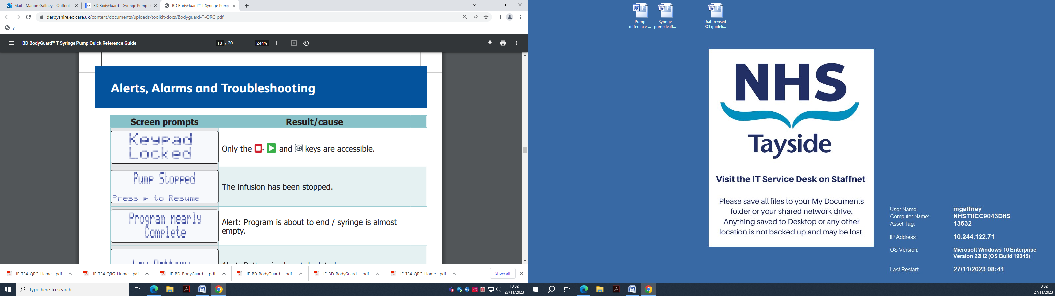

Detailed product information by the manufacturer on how the pump operates can be found here: BD BodyGuard T Syringe Pump Directions for Use

**KEY POINT: The patient/family/carer should be discouraged from interacting with the pump and advised to contact the nursing team caring for them if any issues occur.**

## SECTION FIVE: Monitoring and maintaining the infusion

### 

### 5.1 Monitoring the infusion

The syringe pump is programmed to run over 24 hours. When set up, reloaded or resited an initial check should be carried out within the first 15-30 minutes to ensure the infusion is running correctly. Then every 4 hours in an inpatient setting and at every visit (at least daily) in the community setting.

**Checks to be carried out:**

* Pressing the **i+** key will display volume to be infused and volume infused
* A visual check of the contents of the syringe and extension line for cloudiness, discolouration or precipitation (if noted discard)
* Evidence of redness, swelling, discomfort, leakage at device site
* Battery light is flashing
* Opportunity to review symptom management

Any actions taken should be documented on the syringe pump ‘recording chart’. If an infusion is discontinued before the syringe contents are empty, the amount of any solution remaining should be documented on the recording chart before being discarded.

**KEY POINT: Monitoring the ‘volume infused’ and the ‘volume to be infused’, as well as a visual check, will help to ensure the infusion is running as expected.**

**For patient safety, if the syringe is not empty, disconnect the syringe pump from the patient before removing the syringe.**

### 5.2 Renewing/changing the infusion

The syringe pump medicines require to be changed every 24 hours.

**If there are NO changes required to the prescription only the syringe and contents need to be renewed:**

* Disconnect the subcutaneous extension line from the syringe
* Remove the syringe from the pump
* Refer back to step by step guide for loading the new syringe.

**If there are ANY changes to the prescription:**

**Increased medicine dose(s):**

* Renew the syringe contents as per prescription
* Consider renewing the subcutaneous extension line and leave the existing device in place
* Disconnect the extension line from the syringe
* Remove the syringe from the pump
* Refer back to step by step guide for loading the new syringe

**Addition of new medicine(s):**

* Renew the syringe contents as per prescription
* Consider renewing the subcutaneous extension line
* Consider changing the existing device if there are any medicine compatibility issues
* Disconnect the extension line from the syringe
* Remove the syringe from the pump
* Refer back to step by step guide for loading the new syringe

To prevent an accidental bolus of medicines being given, please ensure the line is not attached to the child or young person’s device when placing the syringe in the pump. All changes must be recorded on the syringe pump ‘recording chart’.

**KEY POINTS: When renewing or changing the syringe it is important to select ‘START INFUSION’ instead of ‘RESUME’ as this will ensure that the syringe pump delivers the infusion over a new 24 hour period.**

### 5.3 Stopping the infusion and removing the syringe pump

When the infusion is nearing completion, a warning will be displayed on the display screen 15 minutes before the end.

When the infusion is complete and the syringe is empty, the pump will stop automatically, and a continuous alarm will sound.

If the syringe pump is no longer required, press  to confirm the end of the infusion, disable the keypad lock, then press and hold the Switch Saymbol - ClipArt Best key until the pump is switched off.

BD recommends keeping the battery in situ when the Bodyguard T syringe pump is not in use, however, please check your local SOP for guidance.

Clean the pump and lockbox (if used) as per cleaning and decontamination guidance (see Section 6.2).

**KEY POINT: For patient safety, if the syringe is not empty, disconnect the syringe pump from the patient before removing the syringe. This prevents the patient from receiving an accidental bolus dose.**

### 5.4 Temporarily stopping and resuming the infusion

This should only be used in exceptional circumstances under the supervision of a registered nurse.

**How to STOP:**

* Press  , disable the keypad lock then press and hold the Switch Saymbol - ClipArt Best key until pump is switched off
* Do not remove the syringe from the syringe pump
* Detach the line from the subcutaneous device
* Ensure both exposed ends are covered with a sterile cap until reconnection takes place
* The pump should be stored in a secure place e.g. a lockable cupboard
* Record the time the syringe pump was stopped on the ‘recording chart’

**How to RESUME:**

* Check the prescription and syringe label match the child or young person’s details.
* Remove the sterile caps and reconnect the line to the device
* Press and hold the Switch Saymbol - ClipArt Best key until the pump switches on
* Select the matching size and brand of syringe using the and arrows
* Press  to confirm
* Select to **RESUME** the previous programme
* Screen will display volume, duration and rate - check against the recording chart
* Press  to confirm
* Screen will display ‘**Start Infusion?**’
* Press  to confirm.
* Note the time the infusion resumed on the recording chart

### 5.5 What to do if a child or young person dies when their syringe pump is running

If the death is expected, the syringe pump can be stopped following the steps in section 5.3. The date, time, amount of solution (ml) remaining and subsequent destruction should be documented on the syringe pump recording chart by professionals present and their witnesses.

If the death is unexpected, or there are concerns about the circumstances of death, the lead nurse/manager should be contacted in or out of hours for advice on how to proceed. All equipment should be left in situ until advised on next steps.

In the community setting, after the child or young person has died, Community Nurses will remove the syringe pump along with any other associated equipment from the home. Families/carers will be asked to return unused medicines to their local community pharmacy.

In a hospital setting, the syringe pump should be returned to the appropriate team / department, such as the equipment library or store.

### 5.6 Child or Young Person Transfer

Children or young people may be transferred between hospital and community settings with a syringe pump in place. It is important to liaise with the teams involved and follow the process agreed for the equipment to be returned safely.

## SECTION SIX: Safety & risk management

### 6.1 Syringe pump maintenance

All syringe pumps must be serviced annually as a minimum. A register of all syringe pumps within each NHS board is maintained by the Medical Physics department who should be notified of any amendments e.g. new pumps, pumps removed from service.

Syringe pumps should be sent for maintenance checks immediately if they have been dropped, suffered fluid ingress (e.g. exposed to fluid) or if there is any doubt regards operation/function.

### 6.2 Cleaning and decontamination

To clean the pump, wipe the external pump surface using disposable wipes impregnated with isopropyl alcohol (IPA) 70%, to minimize pump exposure to excessive quantities of liquids. Isopropyl alcohol is volatile and leaves no residue upon evaporation, therefore surfaces dry quickly after wiping between each use.

* If any additional cleaning is required, contact your local Medical Physics Department and/or Infection Prevention Control Team for advice (e.g. due to contamination with bodily fluids).
* Lockboxes should be cleaned with an alcohol spray or wipe. Cleaning policies may differ. Please follow local advice.

### 6.3 Incident reporting and hazard warnings

Systems are in place in each NHS board to monitor and report incidents involving syringe pumps and staff should be familiar with the local incident reporting system (e.g. DATIX). All incidents must be reported and investigated.

**What defines an incident?**

When a pump is involved in an incident all relevant information should be shared with the Medical Physics department including adverse events and near misses due to a faulty pump or operator error.

**Examples include:**

* Infusions completing ahead of intended time (finishing > 1 hour early)
* Infusions carrying on beyond intended time of completion (carrying on for > 1 hour late, or > 5% of the prescribed medicine remaining in the pump at the end of the infusion period)
* Device not alarming during an alarm condition

Any syringe pump involved in an incident should be removed from use and sent to the Medical Physics Department at the earliest opportunity. Only under exceptional circumstances should the syringe and extension line be sent with the pump which must be discussed in advance. The Medical Physics team can generally obtain the information needed from the software used in the syringe pump.

Where the pump was involved in an incident involving serious harm to the child or young person, the clinical lead should consider contacting the Incident Reporting and Investigation Centre, Health Facilities Scotland before forwarding it to the Medical Physics Department.

Incidents related to prescribing, mixing of medicines and administration must be reported and managed via local incident reporting systems. All healthcare staff have a professional responsibility to report any incidents to their line manager. A clear description of the incident should be provided via the local reporting system.

**KEY POINT: It is important to document any delays or disruptions that prevent the infusion from completing on time as this may influence the decision to report an incident.**

### 6.4 Hazard warning notification

All NHS boards operate a cascade system for hazard warning notifications. Individuals with responsibility for managing areas where syringe pumps are in use must ensure relevant notices are cascaded, reported and acted upon.

## SECTION SEVEN: Alarms and Troubleshooting

### 7.1 Alarm conditions

|  |  |  |
| --- | --- | --- |
| **Screen Prompts** | **Results/cause** | **Possible actions** |
|  | Only the and  are accessible | Disengage keypad lock if further access required |
|  | The infusion has been stopped. | Press the key to Resume  The infusion or press the  key to continue stopped state. |
|  | Alert: Program is about to end/syringe is almost empty. | Prepare to change syringe or discontinue pump use. |
|  | Alert: Battery is almost depleted. | Prepare to change battery. |
|  | Alarm: The pump has been stopped/paused for more than 2 minutes without key presses. | Press the key to resume the infusion, press the  key to continue pause for another 2 minutes. |
|  | Alarm: The program is completed and the VTBI volume is fully infused. | Press the key to confirm, then change syringe or discontinue pump use. |
|  | Alarm: Battery will fail imminently. | Change battery. |
|  | Alarm: One or more of the syringe detection sensors is not detecting. | Check the syringe and place in pump correctly. Check screen messages for assistance. |
|  | Alarm: Clamped line, occluded or kinked. | Release the clamp, flush/replace the access device or clear the occlusion. |
|  | Alarm: Clamped line, occluded or kinked, and the actuator has reached minimum travel position. |
|  | Alarm: An internal system error has occurred. Two examples of system failure screen messages are shown here, refer to pump service manual for a full list of error codes. | The user may be prompted to power off and restart, which may rectify the error. If the error recurs, take pump out of use. Press the **i+** key to obtain error message, record error code and summary of fault and return pump to designated service centre. |

### 7.2 Contacts for advice

Information and guidance on syringe pumps can be accessed via the Scottish Palliative Care Guidelines. In addition, there are a range of sources for advice within your local area. These include:

* Community Children’s Nursing Teams, including Out of Hours Teams
* Hospital Palliative Care Teams
* Hospices
* Pharmacists
* Specialist Palliative Care Teams
* Clinical Nurse Specialists
* Medical Staff
* Medical physics

## REFERENCES

Burgess et al (2020) BMC Medical Education 2020, 20 (Suppl 2):458. Accessed online: <https://doi.org/10.1186/s12909020-02284-1>

Nursing & Midwifery Council (2018) *The Code: Professional standards of practice and behaviour for nurses, midwives and nursing associates.* Accessed online: https://www.nmc.org.uk/standards/code/

## RESOURCES

BD BodyGuard T Syringe Pump Quick Reference Guide:

IF_BD-BodyGuard-T-syringe-pump-comparison-CF05107_BR_EN (1).pdf

BD BodyGuard T Syringe Pump Comparison:

[BD BodyGuard T - BD](https://www.bd.com/en-eu/offerings/capabilities/infusion-therapy/infusion-system-devices/bodyguard-ambulatory-system/bd-bodyguard-infusion-pumps/bd-bodyguard-t)

Chapter 1: Standard Infection Control Precautions SICPs

[National Infection Prevention and Control Manual: Chapter 1 - Standard Infection Control](https://www.nipcm.hps.scot.nhs.uk/chapter-1-standard-infection-control-precautions-sicps/)

[Precautions (SICPs) (scot.nhs.uk)](https://www.nipcm.hps.scot.nhs.uk/chapter-1-standard-infection-control-precautions-sicps/)

Scottish Palliative Care Guidelines:

<https://rightdecisions.scot.nhs.uk/scottish-palliative-care-guidelines/>

Medicines Complete Drug Compatibility Checker: [Medicines Complete - Drug Compatibility Checker](https://www.medicinescomplete.com/#/compatibility).

Association for Paediatric Palliative Medicine Master Formulary: [Home | Association for Paediatric Palliative Medicine (APPM)](https://www.appm.org.uk/)

## A blue text with a white background Description automatically generatedAPPENDICES

### APPENDIX 1: Syringe Pump Version Differences

*Note shorter battery life than previous pumps

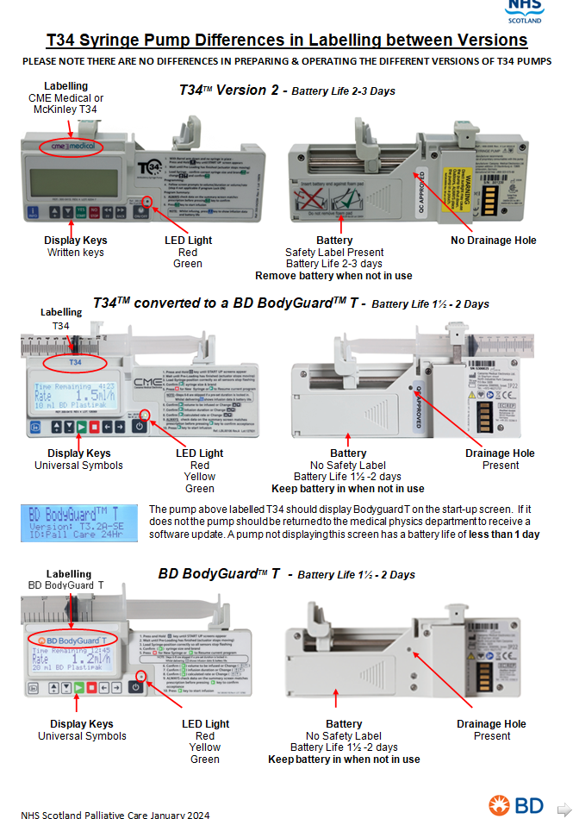

|  |  |
| --- | --- |
| **Version:** | 1.0 |
| **Date Written:** | 22.02.2024 |
| **Review Date:** | 23.02.2025 |
| **Authors:** | Flora Watson / Marion Gaffney |

### APPENDIX 2: Standard Operating Procedure (SOP) Template for Syringe Pumps

This document highlights items for consideration by individual boards, as part of a standard operating procedure or similar, to support the local implementation of the national ‘Guidelines for the use of syringe pumps in palliative care’.

|  |  |  |
| --- | --- | --- |
| **Item** | **Local variation** | **Systems / processes agreed and in place** |
| **DIFFERENT SYRINGE PUMPS AVAILABLE** | **Syringe Pumps:** o CME T34 Version 2  o CME Version 3 o BD BodyGuard T | *\*Staff should be aware of, and familiar with, the syringe pumps used locally* |
| **EQUIPMENT** | **Battery** | *\*Staff should be aware of, and familiar with, battery use as per local systems* |
| Good quality 9 volt (6LR61) alkaline battery: | please specify: |
| Battery left in situ when pump not in use: | o YES (recommended by manufacturer for Bodyguard T) o NO |
| Minimum battery percentage level required at start of infusion: | o 75% or higher |
| **Syringe Size:** | *\*Staff should be aware of syringe sizes used locally & implications of syringe selection i.e. *50ml syringe unlikely to be accommodated with a lock box* |
| o 20ml syringe |  |
| o 30ml syringe |  |
| o 50ml syringe | Assess risk & document any measures put in place: |
| **Infusion equipment**: | *\*Staff should be aware of, and familiar with, infusion equipment used as per local systems and policies* |
| Subcutaneous infusion device: | please specify: |
| Skin prep prior to insertion of subcutaneous infusion device: | o YES please specify: o NO |
| Site dressing: | please specify: |
| Extension line: | please specify: |
| Agreed change interval for extension line: | o 3 Days o Other: please specify: |
| **Lockbox:** | *\*Staff should be aware of, and familiar with, local procedures regarding the use of lockboxes* |
| Plastic Cover: | o YES |
| Fabric Cover (single use): | o YES |
| No cover required: | o YES |
| **KEY**: | o YES Accessed via: |
| **MANAGEMENT OF EQUIPMENT & INCIDENTS** | **Maintenance & Servicing:** | *\*Staff should be aware of, and familiar with, local procedures for maintenance, repair and reporting errors / incidents* |
| **Department** | o Medical Physics / MEMS  o Other please specify: |
| **Reporting System** | o DATIX  o Other please specify: |
| **DEATH OF CHILD OR YOUNG PERSONWHILE SYRINGE PUMP IS RUNNING** | **Syringe pump in situ:** | *\*Staff should be aware of, and familiar with, local procedures for the management of the syringe pump & contents when a Child or Young Person dies* |
| **Expected death:** | The syringe pump can be stopped and removed as per local guidance |
| o Other action(s): please specify |
| **Unexpected death:** | The syringe pump and all associated equipment should be left in situ. Escalate to senior nurse/medical team and await further advice. Check local policy for ‘Care Around Death’ or equivalent. |
|  | o Other Action(s): please specify |
| **RECORD KEEPING** | **Documentation:** | *\*Staff should be aware of, and familiar with, the suite of documents used locally to support the delivery of medicines via a syringe pump i.e. for prescribing, preparing, monitoring and recording* |
| **OTHER(S)** |  |  |
|  |  |  |

### APPENDIX 3: Information Leaflet

**Patient and Family Information Leaflet: Syringe Pump**

|  |
| --- |
| **What is a syringe pump?**  A syringe pump is a small, portable battery-controlled pump which can be carried in a pouch, in your pocket, or placed near you in bed. A syringe and plastic tubing are attached to the pump which gives your medicines through a small tube which is inserted just under the skin. The medicines are then absorbed into your bloodstream. The pump runs 24 hours a day continuously delivering medicines. |
| **Why do I need a syringe pump?**  Sometimes it helps to have medicines through a pump because:   * You have been vomiting (sick) * You are unable to swallow your medicines * Your healthcare team have advised to do so   Medicines are given using the syringe pump to help manage your symptoms when you cannot take your medicines by mouth. |
| **Who will look after my syringe pump?**  You do not need to do anything to the syringe pump. The syringe with the medicines will be changed each day by the healthcare team looking after you. They will check that the small tube under the skin is comfortable and that you are not having any problems with the medicines or the syringe pump.  Sometimes it is necessary to take additional medicines. If you are at home, and still able to swallow, you may be prescribed medicines to take should you experience symptoms. Please let your healthcare team know if you have had to take additional medicines during the day or night. |
| **What does a syringe pump look like?**  The syringe pump is lightweight and around 15cm long by 5cm tall. It may have a clear plastic cover or a fabric bag/pouch for protection. Your healthcare team will be able to show you the syringe pump.  C:\Users\mgaffney\Desktop\01.JPG |
| **How does it work?**  The pump pushes the medicines from the syringe into the plastic tubing and through the small tube under the skin. A light will flash green to let you know the pump is working. The green light will flash as long as there is power in the battery.  If the light changes to yellow or red while the syringe pump is running, the battery will need to be replaced at the earliest opportunity: **PLEASE INFORM THE HEALTHCARE TEAM CARING FOR YOU.** |
| **Please:**   * **DO** keep the syringe pump and the area where the tube goes under the skin dry. If the site accidentally gets wet, just gently pat the area dry with a clean towel. * **DO** take care when washing or bathing to keep the syringe pump dry. If the pump comes in contact with water, let the healthcare team know as soon as possible. * **DO** let the healthcare team know if the syringe pump has accidentally been dropped. |
| **Please:**   * **DO NOT** adjust or alter the syringe pump settings or equipment. All changes will be made by the team caring for you. * **DO NOT** expose the syringe pump and plastic tubing to direct sunlight. You should keep it covered or in the fabric pouch. * **DO NOT** expose the syringe pump to extreme heat. For example, avoid placing next to a heat pad, electric blanket or hot water bottle. |
| **Other important information:**  If you notice any of the following, please inform / contact the healthcare team caring for you:   * The alarm on the pump is activated * The light on the syringe pump is not flashing * There is leakage at the site/dressing where the tube goes under the skin * The skin around the tube is red, swollen and/or painful * The tube under the skin has come out or dislodged * The colour of the liquid in the syringe or the plastic tubing has changed * There is a cloudiness and/or solid bits in the syringe or plastic tubing |
| **\*Please advise the healthcare team caring for you of any problems or concerns so these can be resolved quickly\***  **Your contact numbers for advice and support are:**     |  |  | | --- | --- | | **Healthcare Team:** |  | | **Out of Hours:** |  | |  |  | |

### APPENDIX 4: BD Guidance to Changing Date and Time Setting

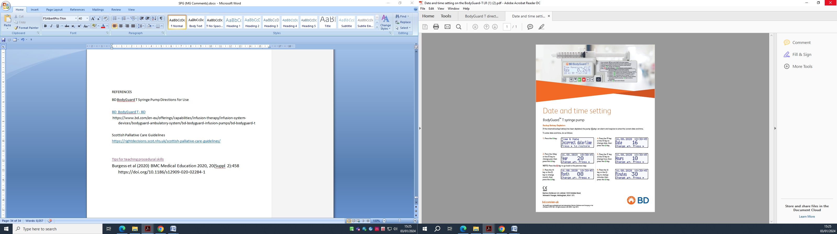

Permission from BD to use

### Appendix 5 – Working Group Members and Approval

|  |  |  |
| --- | --- | --- |
| **Name** | **Role** | **Health Board** |
| Aileen Crichton | Advanced Paediatric Nurse Practitioner | NHS Ayrshire and Arran |
| Caroline Porter | Diana Children’s Nurse | NHS Greater Glasgow and Clyde |
| Elizabeth Gillespie | Team Leader Community Children’s Nursing | NHS Greater Glasgow and Clyde |
| Jenny Gallagher | Team Leader Community Children’s Nursing | NHS Lothian |
| Julie Bisset | Paediatric Oncology Nurse Specialist | NHS Highand |
| Kate McCusker | Lead Pharmacist | CHAS |
| Louise Esson | Diana Children’s Nurse | NHS Grampian |
| Ruth Inness | Palliative Care Nurse Specialist | NHS Lothian |
| Sarah Coy | Paediatric Specialty Doctor | NHS Ayrshire and Arran |

|  |  |
| --- | --- |
| **Group** | **Consultation & Review** |
| PELiCaN CSCI Development Group | Draft document circulated to group following development, minor comments received and final changes made. Document ratified. |
| PELiCaN Steering Group | Draft document circulated to the SG, discussed at meeting where one small amendment was suggested, changes were made and then the document was ratified. |
| Adults Scottish Palliative Care Guidelines Review Group | Draft document circulated to the group via email and was ratified as complete with no further comments. |