Paediatric End of Life managed Care Network (PELiCaN)

Guide to Completing Effective Debriefs following the death of a child or young person

Dr Fiona Herd, Clinical Lead Palliative Care, NHS Grampian, and members of the PELiCaN Service Development Group have created this document. Thank you for your assistance in the development of this guidance.

Contents
Introduction 3
What is a debrief? 3
Types of debrief 3
1. Hot debriefs 3
2. Holistic debrief 4
How long after a death should a debrief be carried out? 4
Who should lead the debrief? 4
Who should attend the debrief? 6
Guiding Principles of Debriefs 6
Format of the meeting 6
What happens next? 7
Refining the debrief process 7
Appendix 1- References for suggested formats 8
Appendix 2- List of Possible Participants 9

The PELiCaN Service Development Group have endeavoured to create as complete a document as possible, however, if you have any constructive feedback or comments on this document this would be greatly appreciated. You can do this by emailing the team on nss.pelican@nhs.scot or by completing the following feedback form. NB: All PELiCaN documents will be subject to NSS document governance and will be subject to regular review.

Version | Description of amendments | Name & Designation | Date
V1 | First Final Version Agreed | Shelley Heatlie | March 2023

Introduction
The death of a baby, child or young person (whether at the end of a palliative illness and expected, or acute and unexpected) is always a significant event. Attention is drawn to ‘Guidance Document- Post Child Death Checklist (NSD610-002.04)’, which describes a comprehensive list of procedures that should be completed after the death of a child.

This guidance document outlines the process for holding effective debriefs following the death of a baby, child or young person. Upon reflection, staff will be able to recount many examples of exemplary practice of multi-disciplinary teamwork, but equally are the lingering negative emotions of stress, guilt, anxiety and sadness in staff. Mental health concerns and burnout are high among health care providers and significant events can lead to anxiety and prolonged trauma responses which can lead to staff absence and errors. There are a number of processes that should be in place to ensure safety of patients, good practice, shared learning and support staff wellbeing. In some cases, a high-level investigative process may be commissioned - for example, a ‘Serious Adverse Event Review’. It is essential that staff helping with any formal investigative process are supported throughout.

What is a debrief?
A debrief is a planned, protected and opt-in confidential meeting space for MDT professionals involved in a patient’s death. It is a non-judgemental opportunity for those staff who wish to participate to reflect; to share emotions; to grieve. It is not a platform for blame or criticism. The rationale of key decisions can be shared, understood, and discussed. Helpful debriefing has been shown to reduce negative effects on staff mental health and improve staff morale, but if done incorrectly it can increase stress and cause harm.

Types of debrief

Hot debriefs
Ideally, a hot debrief should be arranged as soon as possible after the death of the child. A hot debrief describes an immediate debrief of a team or individual after an acute potentially stressful event, for example a resuscitation case or major incident. This can be utilised for other stressful events when felt necessary by a team lead or when requested by any team member involved.

This type of debrief provides a platform for the team involved to give each other feedback on the event, celebrate good teamwork/skills and even allow personnel the safe space to communicate any concerns they may have.

The benefit of the hot debrief is to alleviate the stress these types of situations cause and allow the staff member to go home without any lingering doubts or concerns which could potentially cause a person’s mental health to negatively be affected. Comfort is gained by knowing that colleagues have experienced the same emotional burden: ‘to share is to support’. A hot debrief may help to quickly identify those individuals who may require extra emotional support. Lingering negative feelings of doubt and self-flagellation are detrimental to an individual’s mental well-being; to their resilience; self-esteem and confidence; ultimately, their performance. The hot debrief should be led by the lead consultant or lead nurse and should be brief.
There are a number of tools that can be used to facilitate hot debriefs such as Edinburgh designed STOP5 or a modified version of this called TAKE STOCK (see Appendix 1). In essence it involves a quick summary, identifying good practice and opportunities to improve and a summary of actions.

TRiM
TRiM stands for Trauma Risk Management and originated in the armed forces. It is a peer delivered assessment tool to ascertain whether colleagues have been affected by a traumatic experience and identify appropriate support. Ideally an assessment by a TRiM trained practitioner should take place within 24-72 hrs of a traumatic event but delayed assessment can still be helpful. Most healthcare trusts will have an email inbox for requesting TRiM assessment. It is individual and facilitated by people with no knowledge of the case. It does not focus on the facts of the event but more the consequences for the individual. This can occur alongside the debrief process and is separate, check with your local Board process if TRiM methodology is supported.

Holistic debrief
The holistic debrief aims to allow staff to reflect on an event after a short passage of time. It is confidential, safe and will not primarily inform any investigative process. It should:
- Provide emotional support to staff
- Offer an opportunity to recognise and promote good practice and processes (for example, an action point could be to identify ways to share good practice).
- Highlight potential improvements to practices and processes (for example, if able, asking ‘Could we have done it differently? What would have helped us to do so?)

Key Suggestion: It may be appropriate to focus on (1) or (2) alone if the goal of the debrief is to provide support for the emotional impact of the incident on the staff involved. There is compelling evidence of its positive value if performed correctly.

How long after a death should a debrief be carried out?
Ideally a holistic debriefs should occur 4-6 weeks post death but can happen at any time.

Who should lead the debrief?
It is recommended that there are one or two facilitators in any debrief and that they are individuals who were not involved directly with the case. Anyone can be a facilitator although psychologists may have the most experience initially, but we suggest that institutions arrange training and peer support for a core group of facilitators.

Who should attend the debrief?
Anyone involved with the patient can attend a debrief but consider limiting numbers or offering more than one session, including debriefs for specific staff groups. It is important that everyone involved in the case has the opportunity to attend if they wish to. An example of the large number of health professionals and members that may need to be invited is available in Appendix 2. Some team members can find it very difficult to attend due to working rosters, but managers should ensure access is possible and virtual attendance may help staff to attend on days off if they wish.
It is important that all attendees are offered the chance to participate but no one will be forced to talk during the meeting.

Key Suggestion: For patients who have had a prolonged inpatient stay consider asking the chaplaincy team to facilitate a remembrance service for all staff to be allowed to pay their respects.

Guiding Principles of Debriefs
There are a common set of guiding principles (ground rules) for any debrief:
- Sessions are voluntary
- There is strict confidentiality. The meetings are not recorded, and no minutes are taken
- Respect the etiquette of the meeting, taking turns to talk and respecting the views of all attendees
- There must be no suspicion of blame

Key Suggestion: It may be worth spending a minute or two reiterating these at the start of each session.

Format of the meeting
There are a number of different tools or suggested agendas. All following a similar format (see Appendix 1). The debrief process is to enable staff to
- Discuss the patient story i.e., the experience
- Reflect on thoughts and feelings about the experience
- Analyse the experience

From this you may
- Construct learning points, if everyone consents
- Identify action plans to named person or governance meeting, if everyone consents

What happens next?
If the attendees identify learning points that they wish to share, formal documentation, ratified by all attendees, can be sent to a senior colleague or an appropriate governance group for consideration. The courage and bravery of the attendees to suggest learning points must be awarded equivalent stature and respect. Potential learning outcomes must be considered for action.
The attendees may wish for a second meeting. Staff need to look after themselves and look out for each other. To complement the debrief process, there are several other strategic techniques designed to help staff make sense of what they have witnessed. All can offer differential benefits. Please note this is not a linear process. Many of these support systems can occur simultaneously, and not all will be relevant. It may be wise to signpost staff to further supportive processes, such as personal supervision meetings, well-being and peer support meetings, TRiM, psychology, chaplaincy, occupational health, and other local resources.

Refining the debrief process
A Microsoft Form could be created to allow respondents to complete anonymous feedback on the structure and value of the debrief sessions, questions to include may be
- Was the debrief process useful?
- Was there anything you feel was missed in the debrief process?
- Did you feel that you had a chance to share, if not please state what could have helped with this?
- Any other comments?

Appendix 1- References for suggested formats
Hot debriefs
- NHS, NSS & HPS hot debrief guide - https://www.nipcm.hps.scot.nhs.uk/web-resources-container/hot-debrief-template/
- STOP 5- https://www.edinburghemergencymedicine.com/blog/2018/11/1/stop-5-stop-for-5-minutes-our-bespoke-hot-debrief-model
- TAKE STOCK- https://www.rcemlearning.co.uk/foamed/take-stock-hot-debrief/
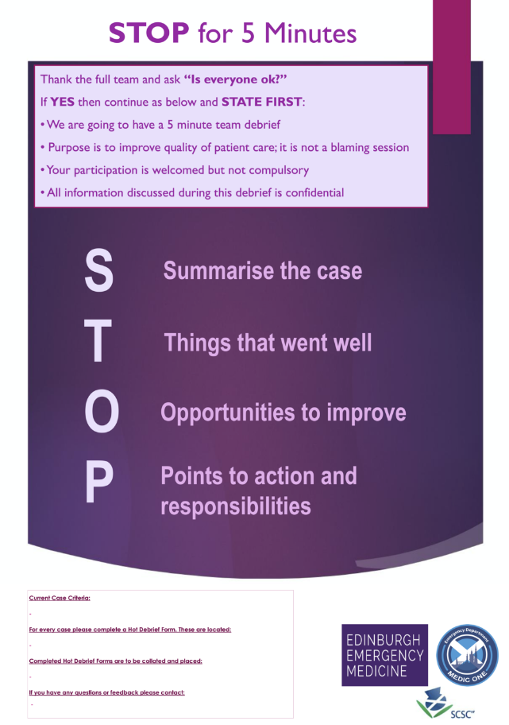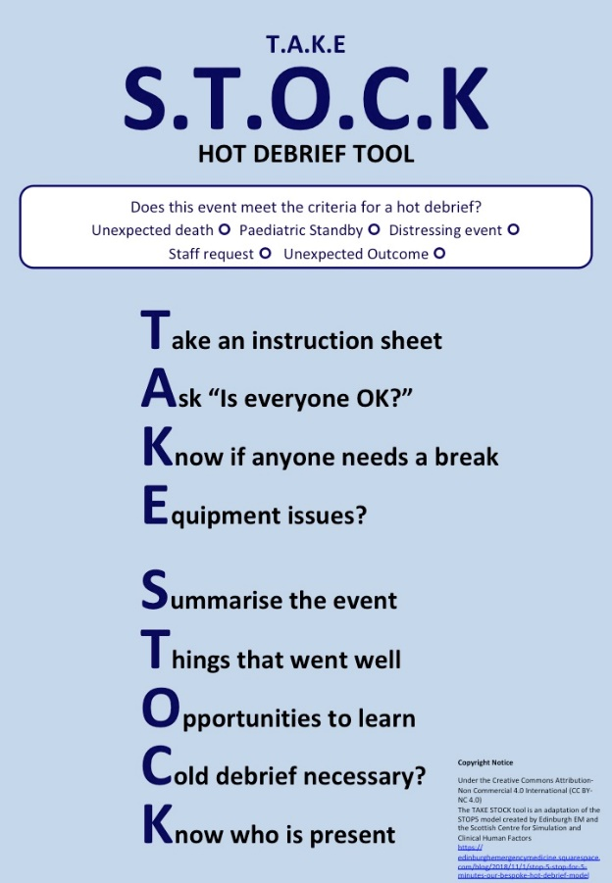

Holistic debriefs
- Keene EA, Hutton N, Hall B, Rushton C. Bereavement debriefing sessions: an intervention to support health care professionals in managing their grief after the death of a patient. Pediatr Nurs. 2010 Jul-Aug;36(4):185-9; quiz 190. PMID: 20860257.
- Morrison, T (2005). Staff Supervision in Social Care. Brighton: Pavilion Publishing.
- Values Based Reflective Practice (VBRP®) handbook available at https://learn.nes.nhs.scot/53958

Appendix 2- List of Possible Participants
- Allied Health Professionals – Dietician, Speech and Language Therapists, Physiotherapists, Occupational Therapist, Psychology
- Ancillary staff – Domestics, Porters, Technicians
- Community staff – General Practitioner (GP), Health Visitors, District Nurses, Paramedics, Community Childrens Nurses
- Carers- including 3rd Sector
- Chaplain or Faith Leaders
- Doctors (from any relevant specialty) at any stage in training, including Surgeons and Anaesthetists
- Education and School teams and staff
- Family Support Teams
- Nurses – Ward, Specialist, Students, Managers
- Non-clinical including Administrators, Secretaries and Ward Clerks
- Pharmacy teams
- Play teams
- Residential and respite staff- including 3rd Sector
- Social workers
- Specialist personnel – Physiologists
- Theatre staff

